Mr. bean
Mr Bean´s alarm went off at 8 o´clock he didn´t listen it so he didn´t got up
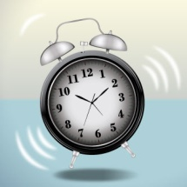
Then he didn´t not got up with the water and then gets up at 9 o´clock 1 hour later.
When he got up he go into the wall then he went to the bathroom after cleaning
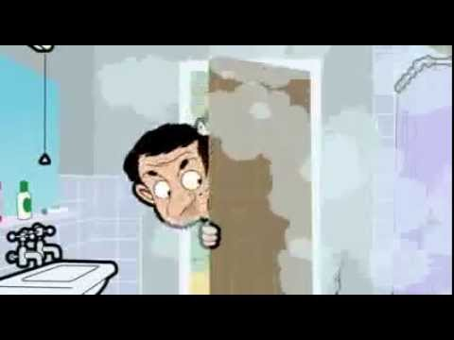
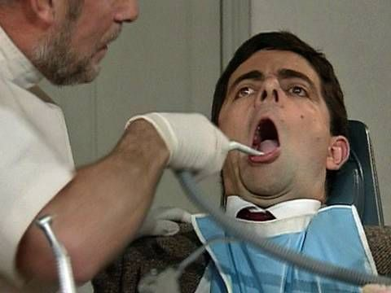
While driving the car was wearing.
Now he is in the dentist and the receptionist say to he-Name
He exclaimed -Bean!
Then he poured water on the boy next to him so he looked he was weeing
On the dentist room the dentist drank a glass of tea then he did sleep to de dentist

SANTIAGO
PAYÁ
(NIA´S CLASS)

